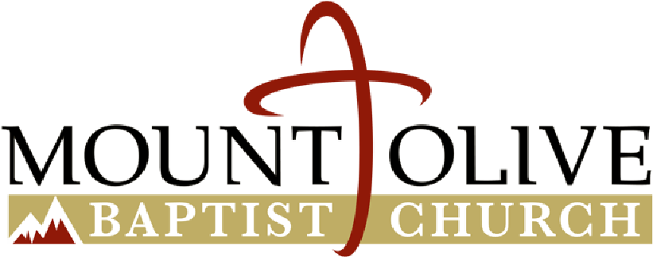

Benjamin Harden Martin and Almeta Ann Hairston Martin Scholarship Fund

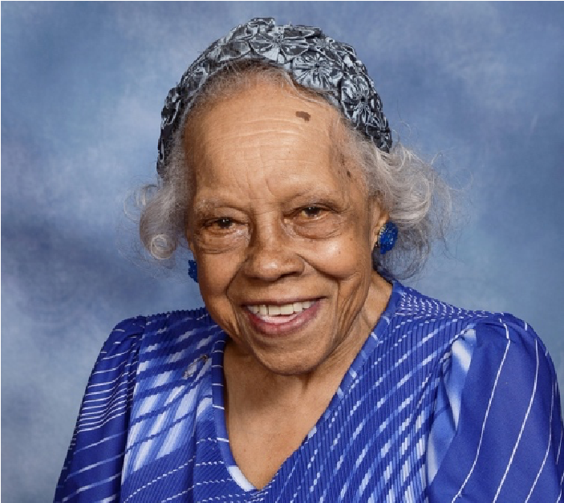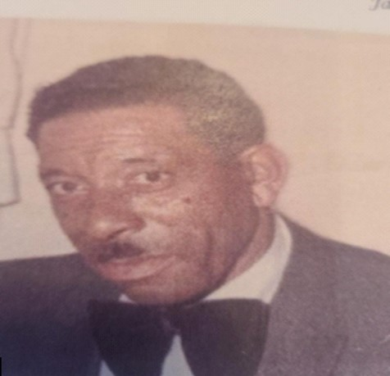

Mount Olive Baptist Church
1601 13th Road South
Arlington, VA 22204
www.mtolivebc.org

A QUIET FAITH THAT SPEAKS VOLUMES:
THE MARTINS’ ENDURING LEGACY

For over 60 years, Benjamin and Almeta Martins’ house has stood through the fast changing landscape of Arlington: a humble, unassuming bridge between the community’s past, present, and future. It’s not that any major historical event took place there, and you’ll find nothing about it in the news. Rather, what makes this house so extraordinary is the couple who called it home for so long, and the local church carrying out their extraordinary gifts of faith.
Benjamin Harden Martin and Almeta Ann Hairston Martin met in Martinsville, Virginia in the late 1940s. Benjamin, a brick mason by trade, was born and raised in Martinsville.
Almeta, a graduate of Bluefield State College (now Bluefield State University), met Benjamin while working as a teacher in Benjamin’s hometown. The young couple married on a hot summer day in August 1948.
Soon after the wedding, Benjamin and Almeta made the move to Arlington, settling into the African American district of Johnson’s Hill: the neighborhood now formally known as Arlington View. Being of strong Christian faith, but of different denominations, the couple quickly sought out their new church homes. Benjamin joined a local Primitive Baptist fellowship, and Almeta became a member of the congregation at Mount Olive Baptist Church right down the street from their house. For the next five decades, Benjamin and Almeta served as steadfast and faithful members of their community.
Benjamin and Almeta continued to be true neighbors to all those around them until the very end, being “every Sunday churchgoers” yet it wasn’t until after their passing – Benjamin in 2011 and Almeta in 2016 – that the full extent of their faith and love for their neighbors was revealed.
In Almeta’s will, alongside the Martins’ nieces and nephews, is the bequest to Mt. Olive
Baptist Church. Specifically, “to be held by said church as a fund to be known as the ‘Benjamin H. Martin and Almeta H. Martin Scholarship Fund’ and the income shall be used to assist needy and deserving students attending college, trade school or vocational school who are members of said church.” Rev. Dr. James E. Victor, Jr., Mount Olive’s Senior Pastor, moved by such generosity, led the congregation to redesign its scholarship program by establishing an endowment in memory of Benjamin and Almeta.
Dr. Victor attests to the value of the Martin gift when he states, “The Martin gift demonstrates that ordinary people often perform extraordinary feats. The radical generosity by the Martins allows us to reimagine the way we handle scholarships and to establish a gift that will keep on giving for generations of Mount Olive students to come.”
Application Criteria
An applicant must:
- Be a member of Mount Olive Baptist Church
- Be accepted by a college, university, or technical school
- Must have a cumulative grade point average of 2.5 or above on a 4.0 grade scale.
Application Checklist
The application and all supporting documents must be received by April 19, 2026.
To be considered for the scholarship, an applicant must submit:
- The Benjamin H. and Almeta Martin Scholarship Application (See below)
- 300–500-word essay (double spaced and typed in 12-point Times New Roman font). Any essay longer than 500 words will not be considered. (Requirement for high school seniors and first year college applicants only).
- Two letters of recommendation (must be from a teacher, counselor, or clergy)
- Community service involvement documentation (see requirement and documentation form)
- An unofficial copy of the applicant’s high school/college transcript indicating the cumulative GPA at time of submission. You will be required to send an official copy when available.
- A copy of your official documentation of acceptance/enrollment in a college, university, or technical school

- Financial Data (page 3)
You can submit your application two ways:
- You can upload the completed forms online at www.mtolivebc.org/scholarship.
- Mail all application materials in a 9”x12” sealed envelope to:

Mount Olive Baptist Church

Attn: Martin Scholarship Committee
1601 13th Road South
Arlington, Virginia 22204

- Applications/Documents Must Be Completed To Be Considered For This Scholarship.

PERSONAL DATA
Full Name Date
Address
City, State, & Zip
Date of Birth
Telephone # __________________________ Cell ____ Home____
e-mail address : __________________________________________________________
Are you a Mount Olive Baptist Church member? ________ Yes____ No____

SCHOLASTIC INFORMATION
Present School & Grade Level ________________________________________
GPA to date _____________
ACT Score ____________ SAT Score _______ National Honor Society Yes ___ No ___

COLLEGE INFORMATION
Colleges /University/Trade/Technical Schools that you will attend, or you plan to attend?
__________________________________________________________________
(**Please attach provide documentation of enrollment to your completed application.)
Do you plan to attend part-time or full-time? _______________________________ Major/Field of Study: __________________________________________________
What year of college/school will you enter? Please check one.
Freshman ___ Sophomore _____ Junior _____ Senior _____
Other: (please explain) ______________________________________________
Annual Tuition Cost: ________________________________
Annual Room and Board Cost: _______________________

FINANCIAL DATA

Anticipated Annual Financial Support during College | Expected family  contribution for the next academic year | $
Anticipated Annual Financial Support during College | Expected student contribution for the next academic year | $

Annual Aid from College or  University  If you DO NOT know this information before your interview with the committee, please skip this section. However, you will need to submit this information should you be awarded a scholarship. | Loans | $
 | Scholarships | $
 | Grants | $
 | Work Study (Yes or No) | $
 | TOTAL | $

List the names and amounts of any outside scholarships:

Additional statement explaining financial need:

APPLICANT CERTIFICATION AND SIGNATURE

I agree to give proof of the information on this application if requested. I give permission to selection committees to review information on this form, my transcripts, and any additional supporting documentation submitted as part of this application. I give permission for selection committees to contact high school and/or college officials for additional academic information.

In the event we are unable to reach you when you are in college, please provide us with a name and contact information of someone who will be able to help us contact you:

Name Telephone # Relationship to the student_

Applicant Signature: __________ Date: _______________

Parent/Guardian Signature________________________________Date:_______________

APPLICANT ESSAY (High School Senior and 1st Year Applicant)

On a separate sheet, prepare your essay. Include your name and Benjamin and Almeta Martin Scholarship Fund Application. The essay should be 300-500 words (double spaced and typed in 12 – point Times New Roman font). Any essay longer than 500 words will not be considered. Your signature is required at the end of the essay.

Essay Prompts (Must be an original essay that uses one of the essay prompts below).
- Benjamin and Almeta Martin were ordinary people who through their bequest performed an extraordinary feat that impacted others. Tell us about an experience you were involved in when your action, accomplishment or achievement had a profound impact on others.
- Reflect on a personal experience where you intentionally expanded your cultural awareness. What did you learn from the experience?
- Identify a problem in your school or community and tell us your role in helping to resolve it.
- Resilience is defined as the ability to adapt and learn from difficulty. Reflect on a time that you have exhibited resilience. What growth did you see in yourself after this experience?

Community Service Requirement (All Applicants)
One of the required components of the Benjamin and Almeta Martin Scholarship is the applicant’s involvement in community service. This requirement is for high school students applying for support and continuing college students in good standing applying for scholarship support. Examples of community service include but are not limited to the following:

High School Students
- Church related - Assisting with Olive Cart prep and food distribution, Reading of church announcements, etc.
- Tutoring of younger students
- Reading to younger students

College or Trade School Students
- Offer Tutoring Services
- Support Donation Drives for those in need.
- Coach Sports for Local Kids
- Volunteer at Homeless Shelters
- Sharing your college experience and insight with middle and high school students

BENJAMIN H. MARTIN AND ALMETA H. MARTIN SCHOLARSHIP FUND

COMMUNITY SERVICE PROJECT AND HOURS FORM

Student Information (Please type or print)
Name: ____________________________________________________ School____________________________________________________

Volunteer Organization Information

Name of Organization: ______________________________________________________

Street Address: ____________________________________________________________

Phone #:__________________________________________________________________

Supervisor’s Name: _________________________________________________________

Email: ___________________________________________________________________

Date | Brief Description of Task | Time In | Time Out | Total Hours

I certify these hours have been completed according to the Mount Olive requirements.
Name of Supervisor __________________________________________________

Title _______________________________________________________________

Supervisor Signature _________________________________________________

